System diagram

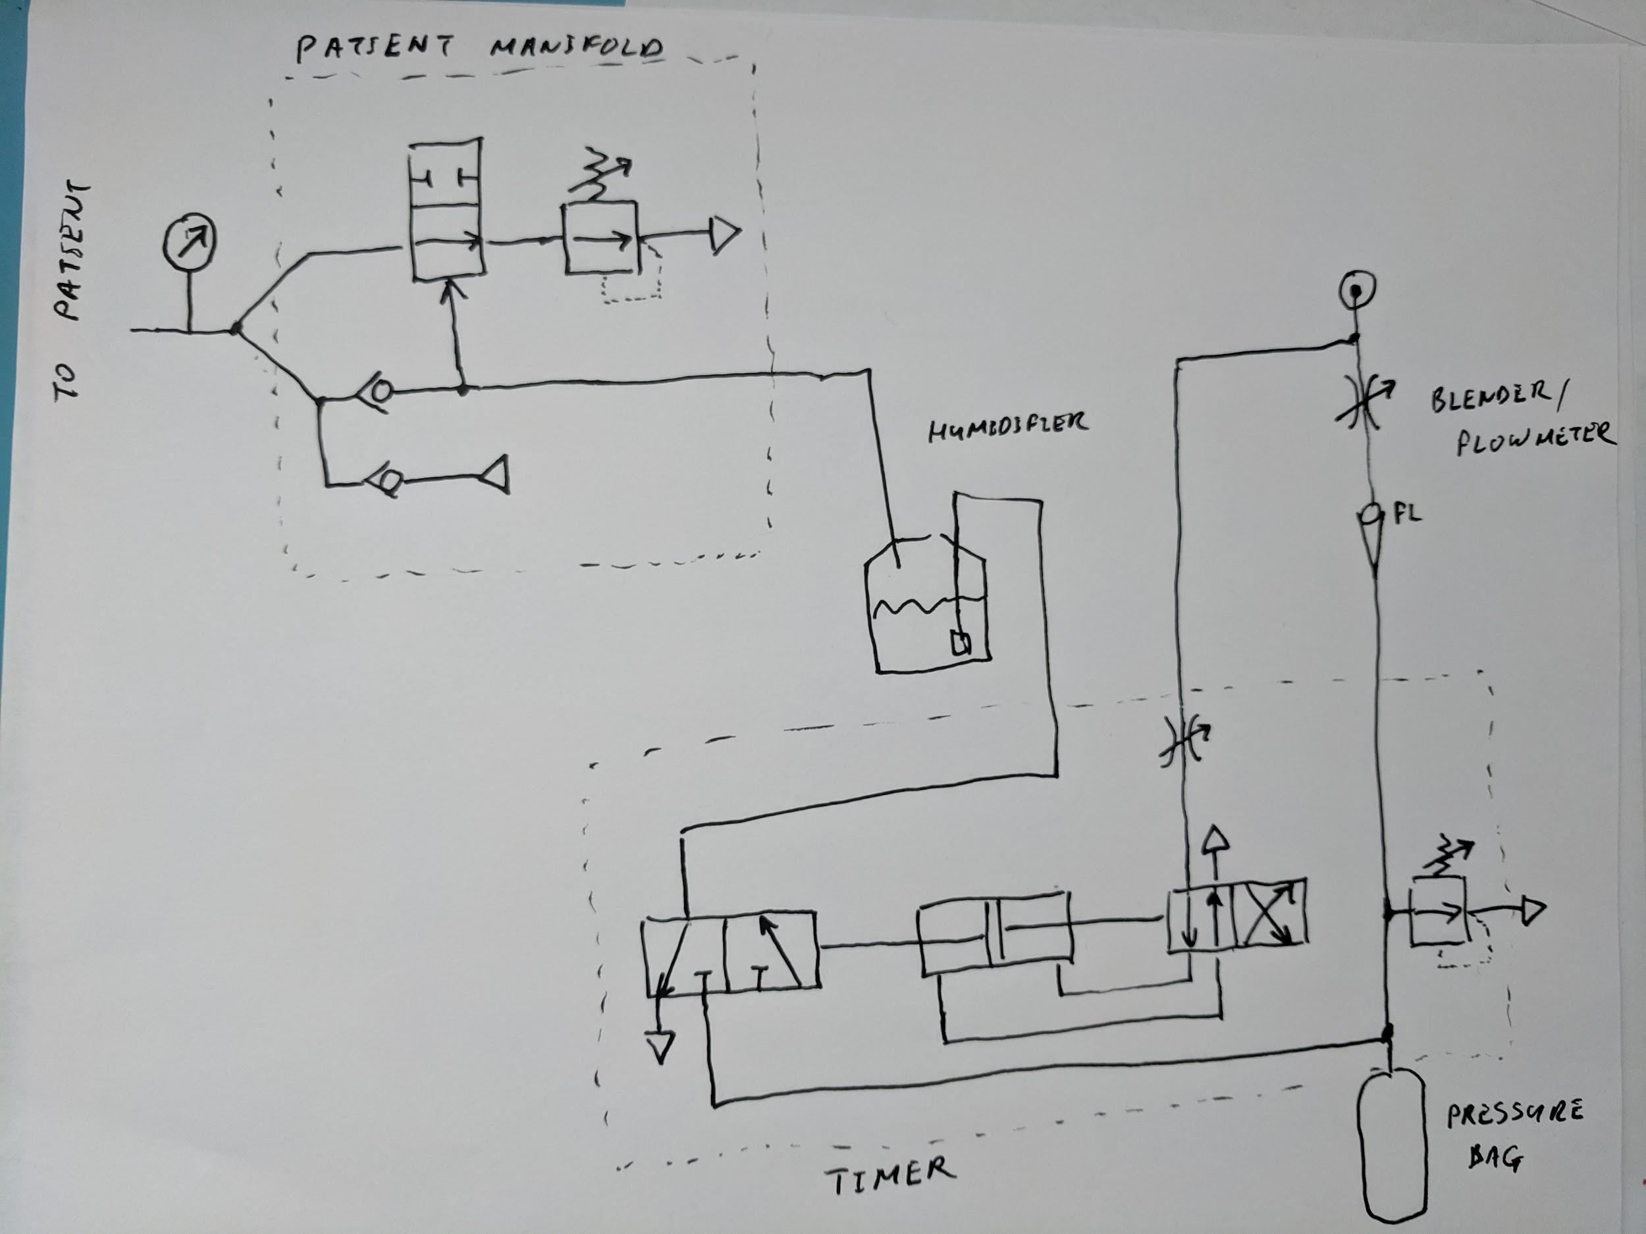

Timer

cycle time 10-30 cycles per second
on time : off time ratio 1:2 (can be fixed or adjustable - change the volume on one side of the cylinder)
driven from 3.5-4.5 bar supply
should not use more than 0.1lpm

Timer pressure relief valve

fixed 35 cmH2O
(option) adjustable 35 cmH2O-70 cmH2O
must allow >10lpm at 40cmH2O

Patient manifold valve

closes at 10 cmH2O or greater
must remain closed with pressure differential up to 35cm H2O between input and output
full port: 100mm^2 (pref 300mm^2)

Patient manifold pressure relief valve (PEEP valve)

adjustable 5 to 20 cmH2O
note: can replace this with water column

Blender

standard equipment:
http://www.biomeddevices.com/products/categories/low-flow-air/oxygen-blenders-for-the-nicu-and-l-d/

Flowmeter

standard equipment:
https://mfimedical.com/products/allied-healthcare-timeter-sure-grip-single-oxygen-flowmeter

Can use direct connection to O2 at 3.5-4.5 bar - in that case flow control valve should reduce flow to 3 - 12 lpm

Pressure bag

standard equipment:
https://serfinitymedical.com/products/portex-anesthesia-breathing-circuit-expandable-tube-87-inch-tube-dual-limb-adult-3-liter-bag-disposable-smiths-medical-453600-nl-653642

Connectors

22mm ID/OD slip fit (standard)

Tubing

Valves

https://www.respiratorycarestore.com/carefusion-001802-airlife-one-way-flutter-valve-large-22mm-o-d

